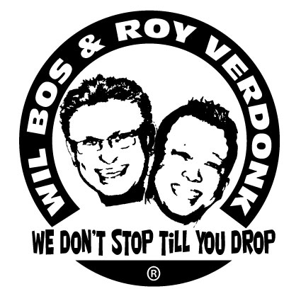
The Golden Age

Choreographers : Roy Verdonk (nl), Wil Bos (nl) April 2012
Level : Easy intermediate,
Walls : 2 Wall
Counts : 64 (no tags No restarts needed)
Music : The Golden Age - The Asteroids Galaxy Tour
Intro : 16 counts

Siderock R, Sailorstep L, Cross behind, 1/4 turn L, Step 3/4 turn L, Behind side cross
1 Rf step right
2&3 Lf step behind Rf, Rf step right, Lf step left
&4 Rf cross behind Lf, make 1/4 turn left stepping Lf forward (9 o'clock)
5&6 Rf step forward, make 3/4 turn left stepping onto Lf, Rf step to right
7&8 Lf cross behind Rf, Rf step to right, Lf step in front of Rf (12 o'clock)

Side rockstep R, Recover L, Step together, Side shuffle L, Cross sailorstep R with 1/4 turn R,
Shuffle forward L
1-2 Rf rock to right, recover onto Lf
&3&4 Rf step next to Lf, Lf step to left, Rf step next to Lf, Lf step to left
5&6 Rf cross in front of Lf, make 1/4 turn right stepping Lf back, Rf step right (3 o'clock)
7&8 Lf step forward, Rf step together, Lf step forward

Full turn L, Syncopated rocksteps, Cross shuffle, Scissorstep with 1/4 turn L
1&2 Make ½ turn left step Rf back, make ½ turn left step Lf forward, Rf step forward
(optional : shuffle forward R)
3&4& Lf rock forward, recover onto Rf, Lf rock left, recover onto Rf
5&6 Lf cross in front of Rf, Rf step right, Lf cross in front of Rf
7&8 Rf step to right, make 1/4 turn left step Lf next to Rf, Rf step forward (12 o'clock)

Syncopated locksteps forward L and R, Syncopated cross sailorsteps backwards with 1/4 turn R, Cross
1&2 Lf step diagonally forward left, Rf lock behind Lf, Lf step diagonally forward left
&3& Rf step diagonally forward right, , Lf lock behind Rf, Rf step diagonally forward right
4 Lf scuff next to Rf
5&6 Lf cross in front of Rf, Rf step diagonally back right, Lf step diagonally back left
&7& Rf cross in front of Lf, Lf step diagonally back left, Rf step diagonally back right
8 make 1/4 turn right crossing Lf in front of Rf (3 o'clock)

Side, Together, Side, Touch, Side, Together, Side with kick R, Sailor R with 1/4 turn R, Mambo with 1/4 turn R
1&2& Rf step right, Lf step together, Rf step right, Lf touch together
3&4 Lf step to left, Rf step together, Lf step to left kicking Rf to right
5&6 Rf cross behind Lf, make 1/4 turn right stepping Lf back, Rf step to right (6 o'clock)
7&8 Lf step forward, make 1/4 turn right stepping onto Rf, Lf cross in front of Rf (9 o'clock)

Side, Together, Side, Touch, Side, Together, Side with kick R, Sailor R with 1/4 turn R,
Step forward with 1/2 turn R, Cross
1&2& Rf step right, Lf step together, Rf step right, Lf touch together
3&4 Lf step to left, Rf step together, Lf step to left kicking Rf to right
5&6 Rf cross behind Lf, make 1/4 turn right stepping Lf back, Rf step to right (12 o'clock)
7&8 Lf step forward, make 1/2 turn right stepping onto Rf, Lf cross in front of Rf (6 o'clock)

Touch side, Touch together , Touch Side, Cross samba, Syncopated weave with 1/4 turn L
1&2 Rf touch right, Rf touch together, Rf touch right
3&4 Rf cross in front of Lf, Lf step to left, Rf step to right
5&6&7 Lf cross in front of Rf, Rf step right, Lf cross behind Rf, Rf step right, Lf cross in front of Rf
&8 Make 1/4 turn left stepping Rf back, Lf step to left (3 o'clock)

Toe fan R, Toe fan L, Scuff hitch step back, Coaster L, Step R with 3/4 turn L
1& Rf touch heel forward with toes in, step onto Rf with toes out
2& Lf touch heel forward with toes in, step onto Lf with toes out
3&4 Rf scuff next to Lf, Rf hitch knee, Rf step back
5&6 Lf step back, Rf step together, Lf step forward
7-8 Rf step forward, make 3/4 turn left step onto Lf (6 o'clock)

